Document management process |  |  |  |  |  |  |  |  |  | 
Document no |  |  | RS-SP-01 |  |  |  |  | Written by |  |  |  | Mark.Kim
Rev no |  |  | 001
Rev. date | 2022.09.22 |  |  |  |  |  |  | Department |  |  |  | QM
Revised contents |  |  |  |  |  | Drift |  |  | Review |  |  |  | Approval
 |  |  |  |  |  | / |  |  | / |  |  |  | /
Revised Items | AS IS |  |  |  |  | TO BE
Agreement | QM | R&D
 | Opinion:


[Revision history]
Revision history summary |  |  | RS-SP-01
 |  |  | Revision | 001
 |  |  | Confidential | G1
Rev. no | Rev. date | Simple description of changed contents | Author | Post
001 | 2022.09.22 | Newly established. | Mark.Kim | QM

1. Purpose and scope
This regulation is for the definition of documents established by ramschip and efficient document management.

2. Apply scope
Applies to all documents issued by ramschip.

3. Definition of terms
3.1 Standard or Process
Documents describing procedures and rules necessary for quality management activities.
3.2 Report
Review & evaluation reports generated during quality management activities.
3.3 Record
A document prepared to prove this in performing a specific working.
3.4 preserved documents
Document to be kept for the history record.
3.5 Preservation period
Management and keeping period of the document.

4. Relevant form
N/A

5. Responsibility and authority
5.1 CQO (Chief quality officer)
1) Responsibility and authority to monitor whether document management is carried out
effectively.
2) Responsible for preservation and management until the expiration of the retention period of the document.
5.2 All of division manager.
1) Have the responsibility and authority to prepare and review the document and approve the establishment of the document.
2) All of division manager is responsible for keeping various documents and should monitors whether they are maintained.

6. Classification of documents.
Classification#1 | Classification #2 | Description
Standard | COP | Customer oriented process
 | MP | Management process
 | SP | Support process
 | WI | Work instruction
General document | Report | All of papers which are made by engineers or employee.

7. Process mapping for standard update.
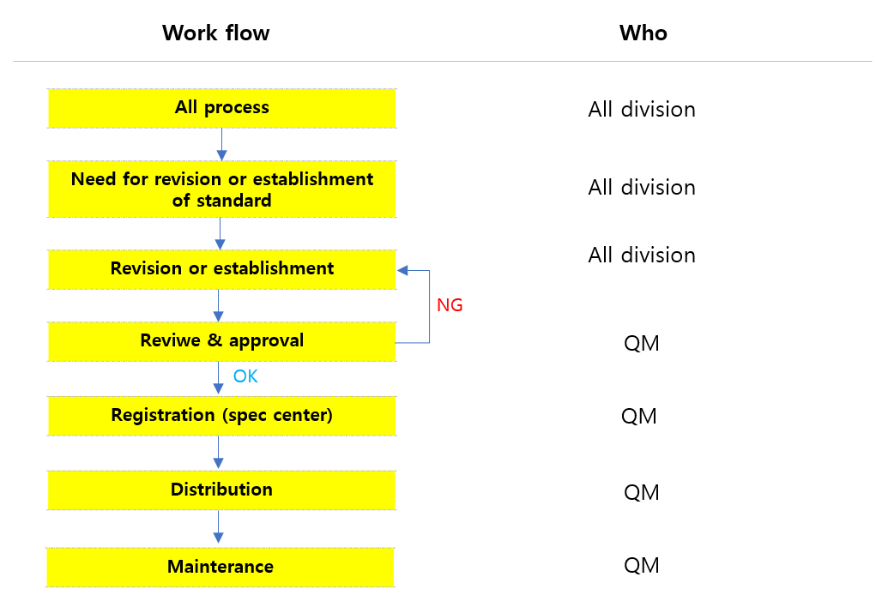

Phase | Input | Process | Output | Process  owner | Support team
P1 | All process | -. Each department prepares a document by reviewing whether it is consistent with the requirements of IATF16949 and whether it is related to the quality manual when the reason for revision or establishment of the process or standard. | Revised or established  process | Each dept. | QM
P2 | Revised or established  process | -. When establishing the process, the drafting department inquires the standard number to spec center and is given it. | Release new process numbers. | Each dept. | QM
P3 | Release new process numbers. | -. The drafting department submits the prepared standard to the spec center.  -. The spec center reviews the standard received.  -. If received standard have a abnormal contents, spec center should request revision to the drafting department. | Feedback on review  results. | QM | Each team
P4 | Feedback on review  results. | -. If there is no abnormality in the final received standard,  It is registered at the spec center after approval of CQO. | Final version standard | QM | Each team
P5 | Registered  Standard | -. Distribute the updated standard to relevant department. | Final version standard | QM | Each  team
P6 | Final version standard | -. The QM must manage the updated standards in the spec center to avoid change and deletions in content. | Spec center | QM | -

7.1 Process establishment
1) When it is necessary to implement a new working process system and standardize existing working process.
2) In case of working improvement, organizational change, process change, etc.
3) In case there is a change in the relevant standard, national standard or regulation.
4) When the need for standardization regarding any activities.

7.2 Process revision.
1) In case of finding any abnormality or improvements to the content, system, and operationt of the current
registered standard.
2) When management working, manufacturing process and specifications are changed or other reason for revision occur.
3) In case of working improvement, process chagne, etc.

8. Structure of document.
8.1 Doucment structure.
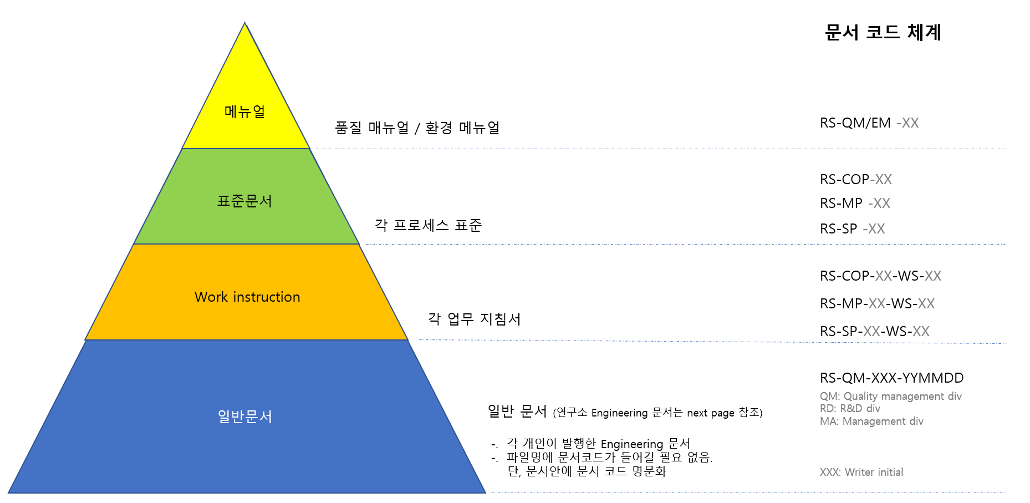

8.2 R&D documents rule
(Category)-(Project)-(yymmdd)-(Title)-(Owner)
Category | Project | yymmdd | Title | Owner
-. SEM: Seminar  -. TR: Technical report  -. DN: Design note  -. TRN: Training  -. MT: Meeting | -. Assigned 3digits by PL(Project leader)  -. In case of personal paper: P+xx  (XX: defined by writer) | (Written date)  6 digits | Subject | Writer name initial

9. Confidential grade.
Classification | Grade | Description | Remark
Top secret | G0 | -. Only share with related team.  -. Distribution in not possible without the approval  of the CEO. Especially external distribution.  [Ex: Project document, Document include core design concept or circuit, new technology] | Never distribute anywhere  Without approve CEO
Confidential | G1 | -. Documents that can only be shared within the  Company.  -. Can be distributed after approval by the department head.  [Ex: Technical report] | N/A
 | G2 | -. Documents that can be distributed to companies with which NDA (Non-disclosure agreement) is signed. | N/A
General | G3 | -. Documents that can be distributed externally without the approval of the department head. | N/A

10. Preservation period of the document
Classification | Grade | Period | Preservation division
Top secret | G0 | Permanent | Each division
Confidential | G1 | Permanent | Each division  [Quality manual, Process, work instruction – QM]
 | G2 | ~ 3 years | Each division
General | G3 | ~ 3 years | Each division

- end -

